## Front End Engineering-II

Project Report

Semester-IV (Batch-2022)

Title of the Project: MoCart



**Supervised By: Submitted By:**

Raveesh Samkaria Name: Tanisha

Roll no: 2210990891

Group: G-13

**Department of Computer Science and Engineering**

## Chitkara University Institute of Engineering & Technology,

## Chitkara University, Punjab

**CONTENTS:**

|  |  |  |
| --- | --- | --- |
| **S.NO** | **CONTENT** | **PAGE.NO** |
| **1** | **Abstract** | **3** |
| **2** | **Introduction** | **4-5** |
| **3** | **Problem Definition and Requirements** | **6-7** |
| **4** | **Proposed design** | **8** |
| **5** | **HTML code** | **9-17** |
| **6** | **CSS code** | **18-25** |
| **7**  **8** | **Result**  **Reference** | **26-30**  **31** |

**Abstract:**

**1. HTML Structure:**

- The HTML document includes various sections such as header, hero section, navigation bars, product listings, and footer.

- It uses semantic HTML elements like `<header>`, `<footer>`, `<nav>`, `<ul>`, `<li>`, and `<div>` for structuring the content.

- The header contains navigation bars, a logo, search functionality, and contact information.

- The hero section displays featured deals with images and pricing.

- Product listings are categorized and displayed in separate sections.

- The footer includes several panels with links to different sections of the website and social media icons.

**2. CSS Styling:**

- CSS is used to style the HTML elements, defining their appearance, layout, and responsiveness.

- Styles are applied for colors, fonts, spacing, backgrounds, borders, and alignment.

- Flexbox and grid layout techniques are utilized for arranging elements in rows and columns.

- Media queries are likely used to make the page responsive to different screen sizes.

**3. External Dependencies:**

- External CSS libraries like Font Awesome and Remixicon are linked for icons.

- Images are linked within the HTML structure for visual content.

Overall, the code aims to create a visually appealing and functional e-commerce website with navigation, product showcasing, and contact information.

**Introduction:**

**In the ever-evolving landscape of commerce, the digital realm has emerged as a pivotal platform for businesses to thrive and consumers to access goods and services conveniently. Among the myriad forms of digital commerce, e-commerce stands out as a cornerstone, offering unparalleled accessibility and flexibility. This project endeavors to delve into the realm of e-commerce development, aiming to construct a robust and user-centric online shopping platform that caters to the diverse needs of modern consumers and businesses.**

**Background:**

**The proliferation of the internet and technological advancements have revolutionized the way people conduct transactions and interact with businesses. Gone are the days when physical storefronts were the primary means of retail. Today, the virtual marketplace reigns supreme, providing a global stage for businesses of all sizes to showcase their offerings and connect with a vast audience.**

**In this digital milieu, e-commerce platforms have emerged as the cornerstone of modern retail. These platforms offer businesses the opportunity to transcend geographical boundaries, target niche markets, and streamline their operations. From small artisanal craftsmen to multinational corporations, e-commerce has democratized the retail landscape, empowering entrepreneurs and consumers alike.**

**However, amidst the burgeoning e-commerce ecosystem, the need for innovative, user-friendly, and secure platforms has become paramount. Consumers demand seamless browsing experiences, intuitive interfaces, and robust security measures to safeguard their sensitive information. Simultaneously, businesses require scalable solutions that can adapt to evolving market trends, manage diverse product catalogs, and facilitate seamless transactions.**

**Objective:**

**The primary objective of this project is to design and develop an e-commerce website that transcends the conventional norms, offering a comprehensive suite of features and functionalities tailored to meet the dynamic needs of modern commerce. Specifically, the project aims to achieve the following objectives:**

**1.User-Centric Design: Implement an intuitive and visually appealing user interface that enhances the browsing and purchasing experience for consumers across diverse demographics.**

**2. Robust Product Management: Develop a robust backend system equipped with advanced product management capabilities, including inventory tracking, categorization, and dynamic pricing.**

**3. Secure Payment Processing: Integrate industry-leading payment gateways and encryption protocols to ensure the secure transmission of sensitive financial information and safeguard against cyber threats.**

**4. Responsive and Scalable Architecture: Design the e-commerce platform with a responsive layout and scalable architecture, ensuring seamless compatibility across various devices and accommodating future growth and expansion.**

**5. Enhanced Customization Options: Provide businesses with the flexibility to customize their storefronts, product listings, and promotional campaigns, enabling them to establish a unique brand identity and cater to specific customer preferences.**

**Significance:**

**The significance of this project lies in its potential to revolutionize the e-commerce landscape, offering businesses and consumers alike a platform that transcends conventional boundaries and sets new standards of excellence. By delivering a user-centric, feature-rich e-commerce solution, this project aims to:**

**- Empower businesses to reach new markets, expand their customer base, and drive revenue growth through enhanced online visibility and engagement.**

**- Enhance the shopping experience for consumers by providing a seamless, secure, and personalized platform that caters to their individual preferences and needs.**

**- Foster innovation and collaboration within the e-commerce community, driving the evolution of digital retail and shaping the future of commerce in the digital age.**

**In essence, this project aspires to be more than just another e-commerce platform; it aims to be a catalyst for positive change, ushering in a new era of commerce characterized by innovation, inclusivity, and empowerment.**

**Problem Definition and Requirements**

**Problem Statement:** The provided code implements a basic e-commerce website, facilitating the online sale of products. The problem involves designing and developing a web-based platform that allows users to browse, search for, and purchase various products. The platform should offer an intuitive user interface, efficient product management, secure payment processing, and responsive design across multiple devices. Additionally, the system should be scalable and maintainable to accommodate future growth and updates.

**Software Requirements:**

**1. Programming Languages and Frameworks:**

- HTML, CSS, JavaScript for frontend development.

**2. Development Tools:**

- Integrated Development Environment (IDE) such as Visual Studio Code, PyCharm, or Sublime Text.

- Version control system like Git for collaborative development and code management.

- Package managers for installing and managing dependencies (e.g., npm, pip).

**3. Web Server:**

- Apache, Nginx, or similar web server software to serve web pages to clients.

**Hardware Requirements:**

**1. Server Infrastructure:**

- Sufficient computing resources to host the web application, including CPU, RAM, and storage.

- Considerations for scalability and high availability, such as load balancers and redundant servers.

**2. Networking:**

- Reliable internet connectivity with adequate bandwidth to handle user traffic and data transfer.

**3. Security Measures:**

- Firewalls, intrusion detection systems, and encryption protocols to protect against security threats and data breaches.

**Proposed Design / Methodology** 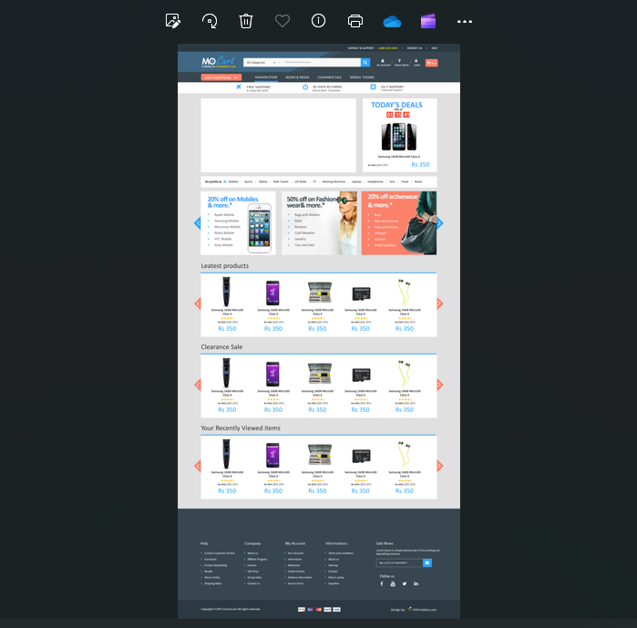

**Source code:**

**HTML CODE:**

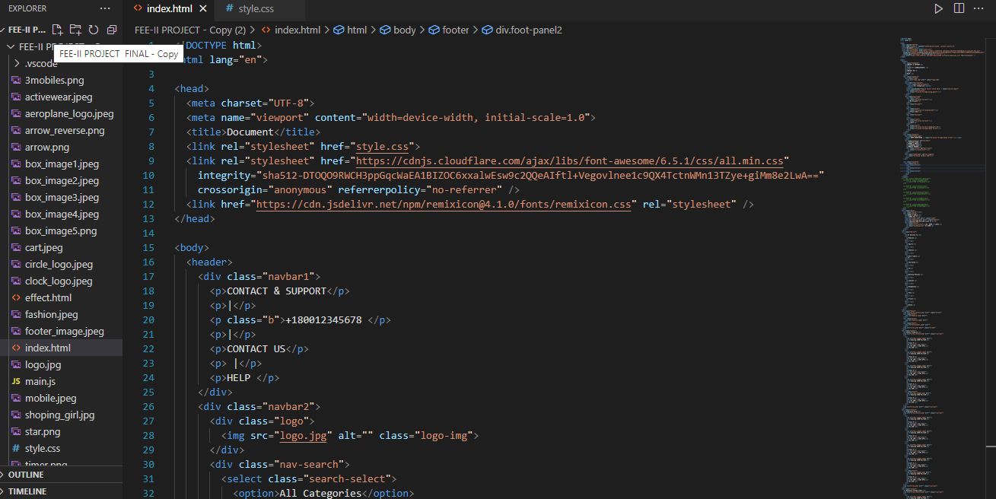

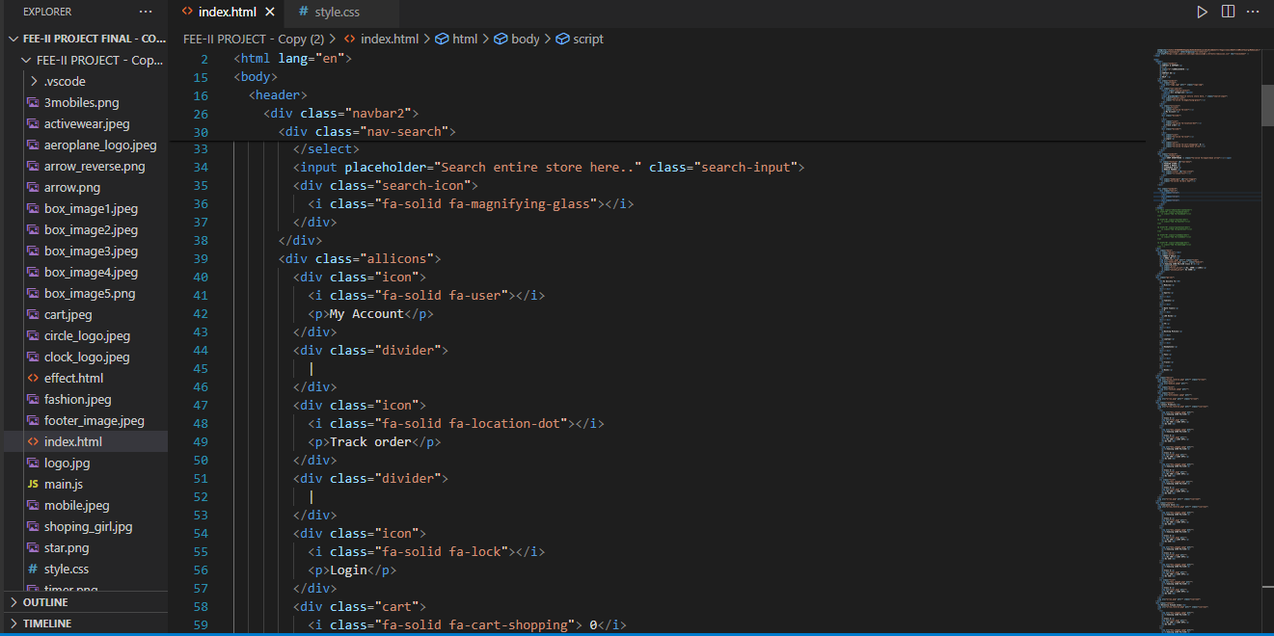

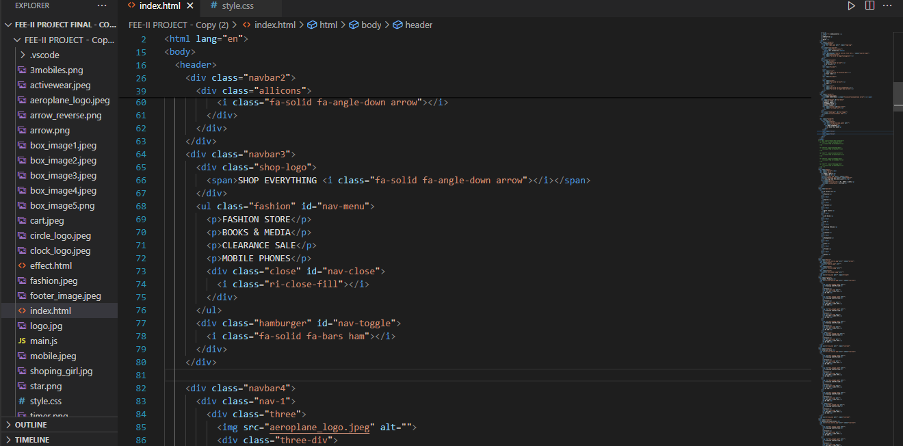

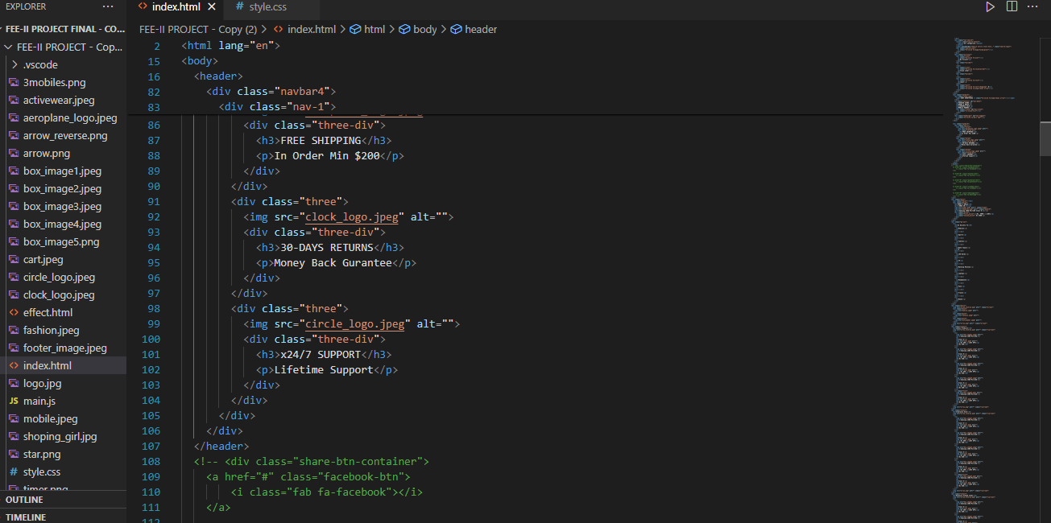

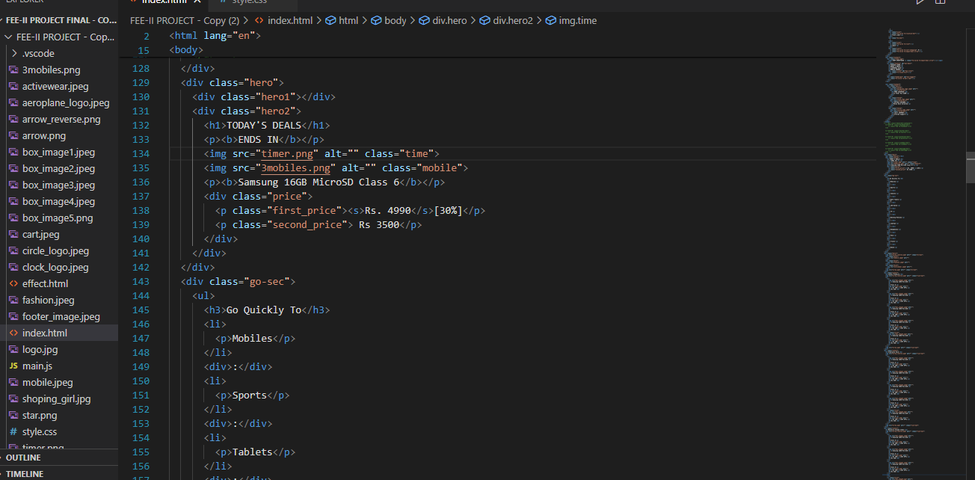

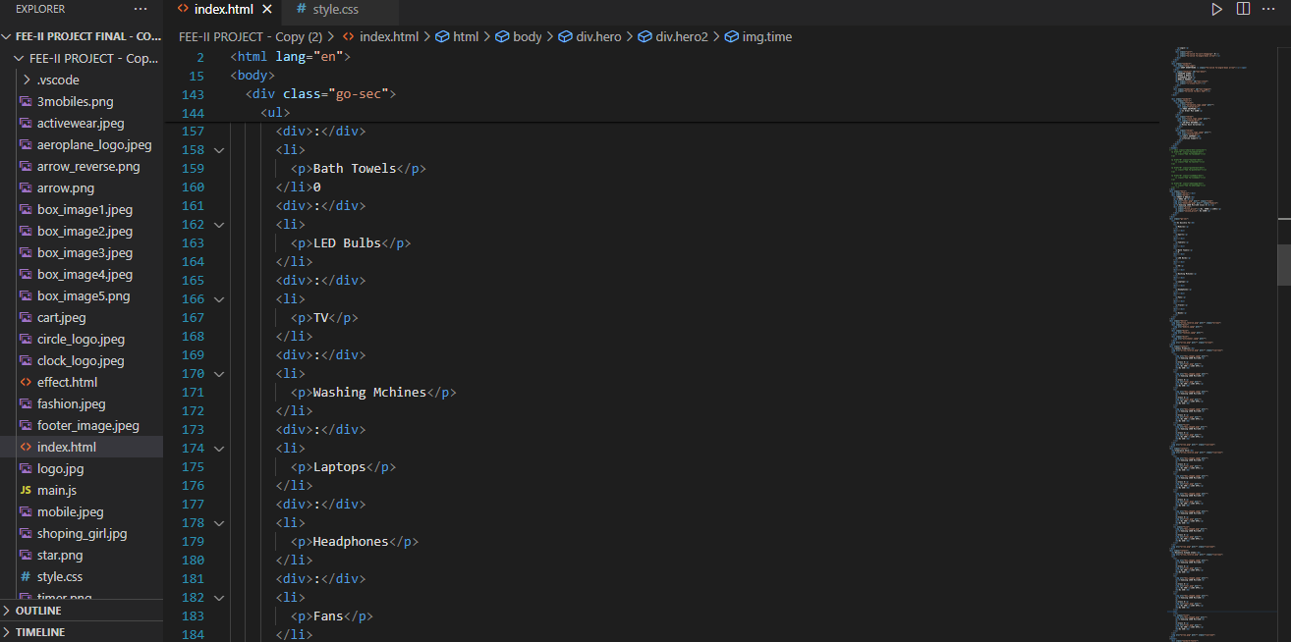

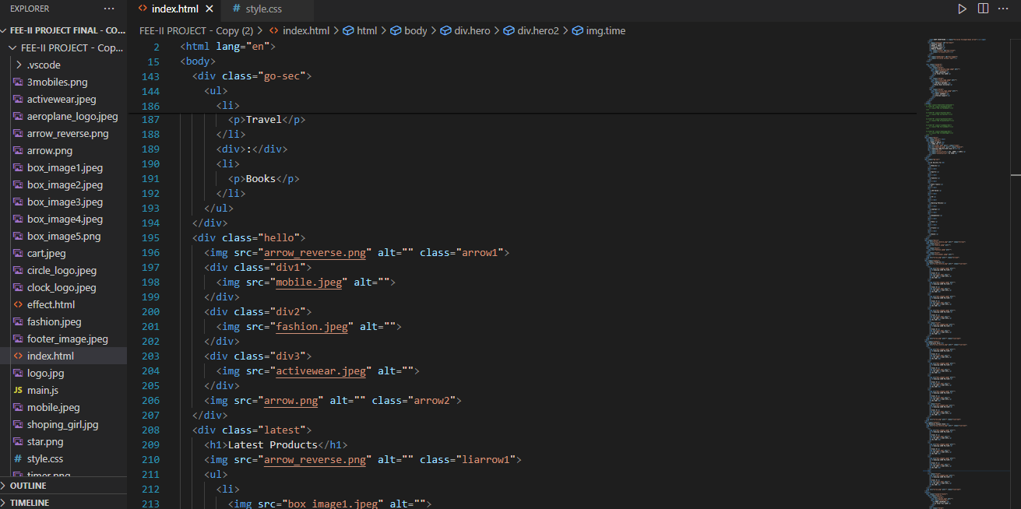

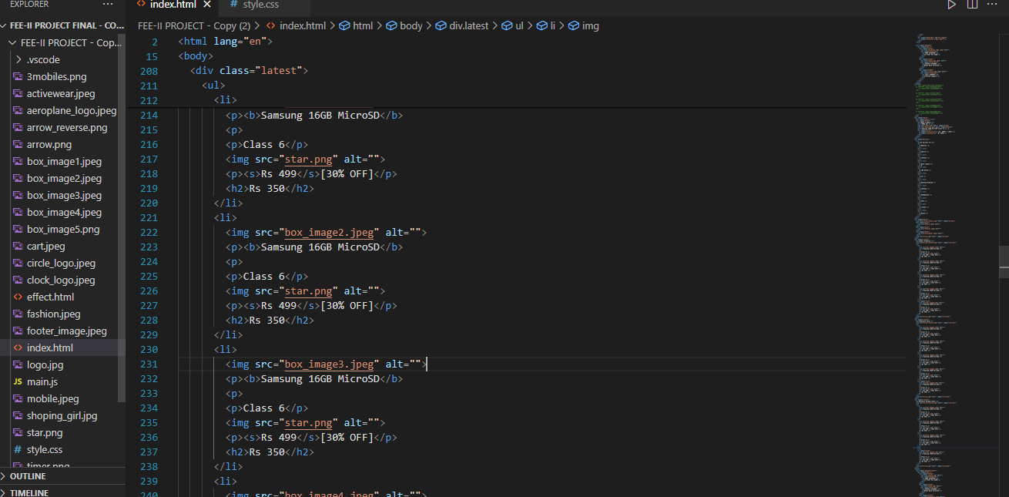

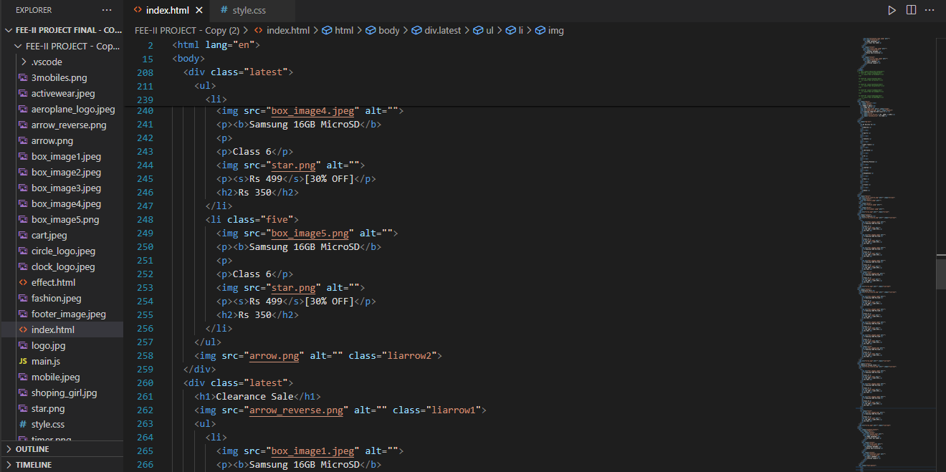

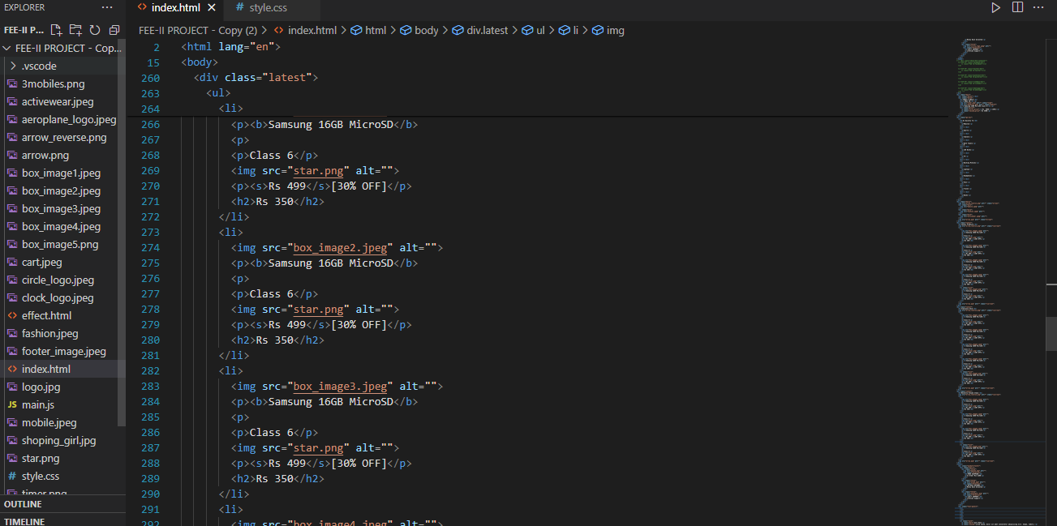

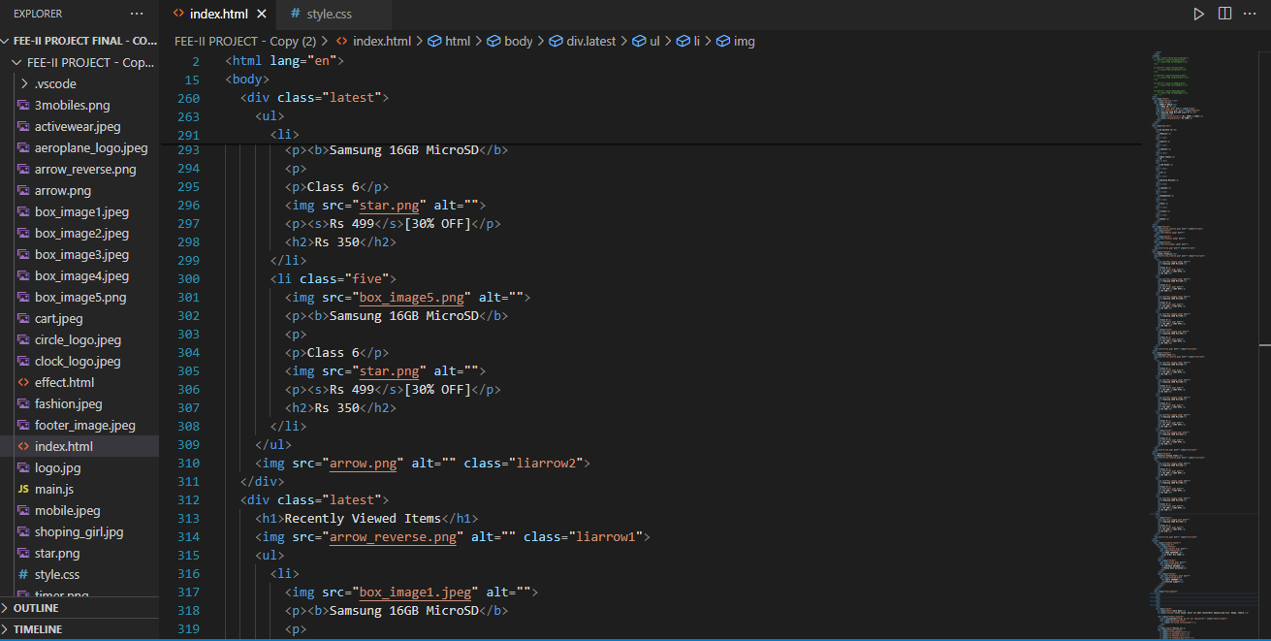

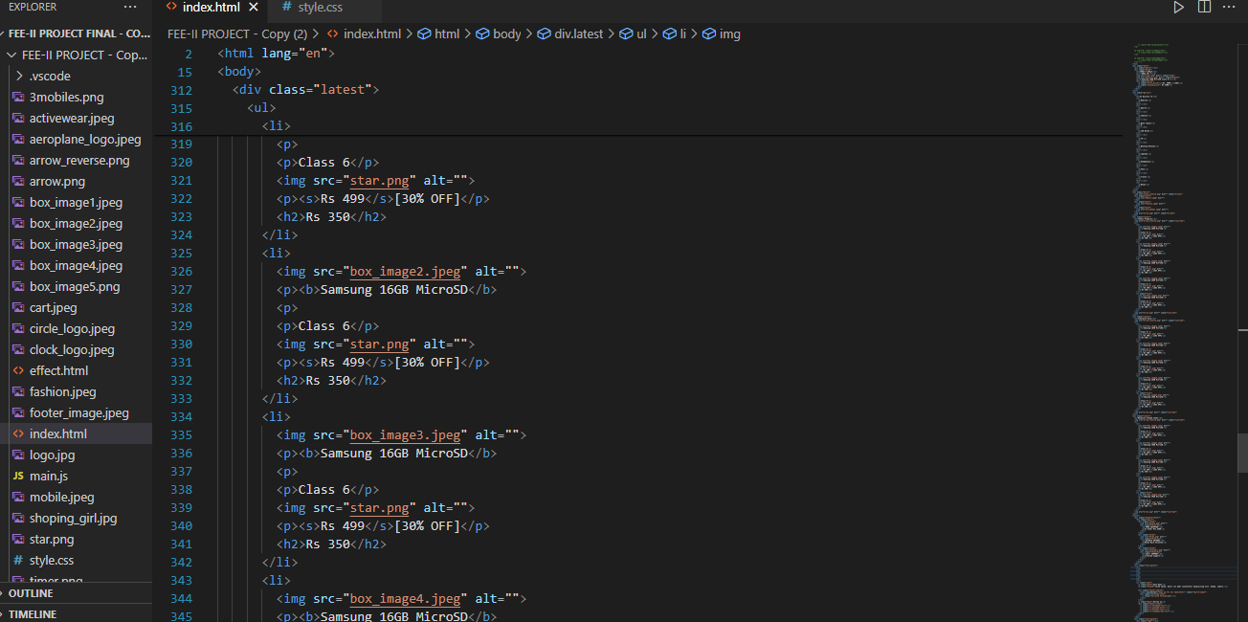

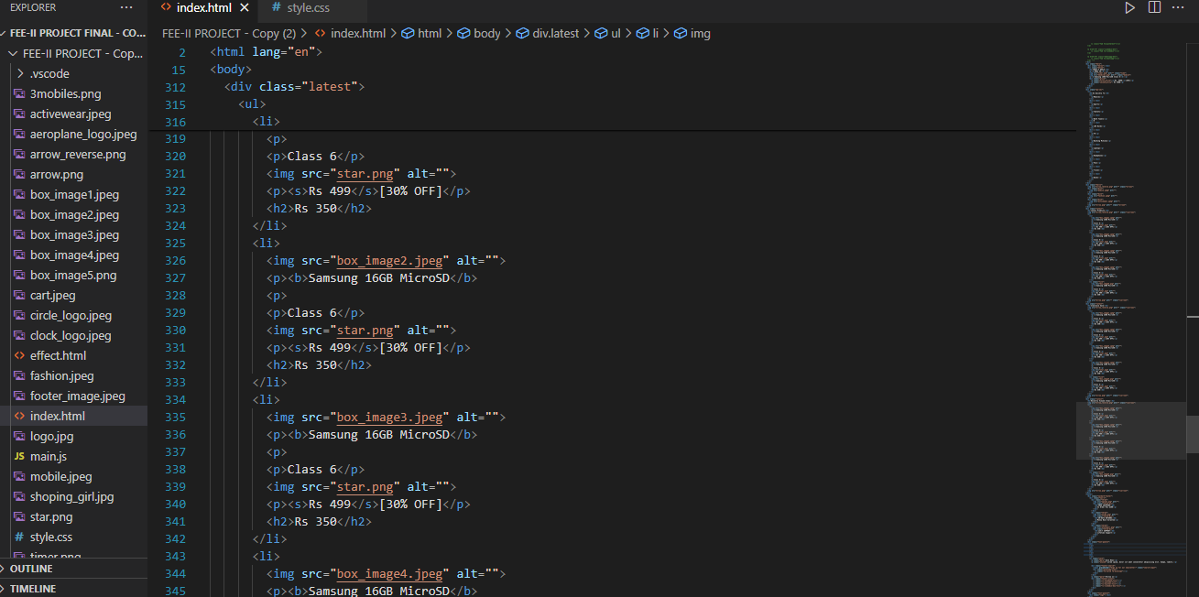

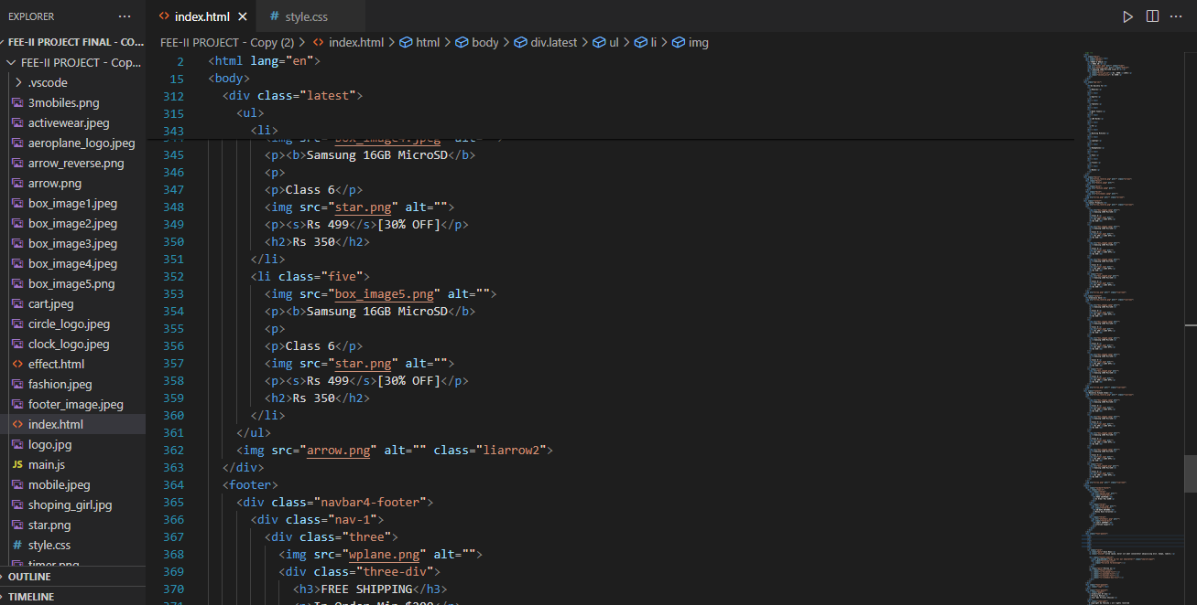

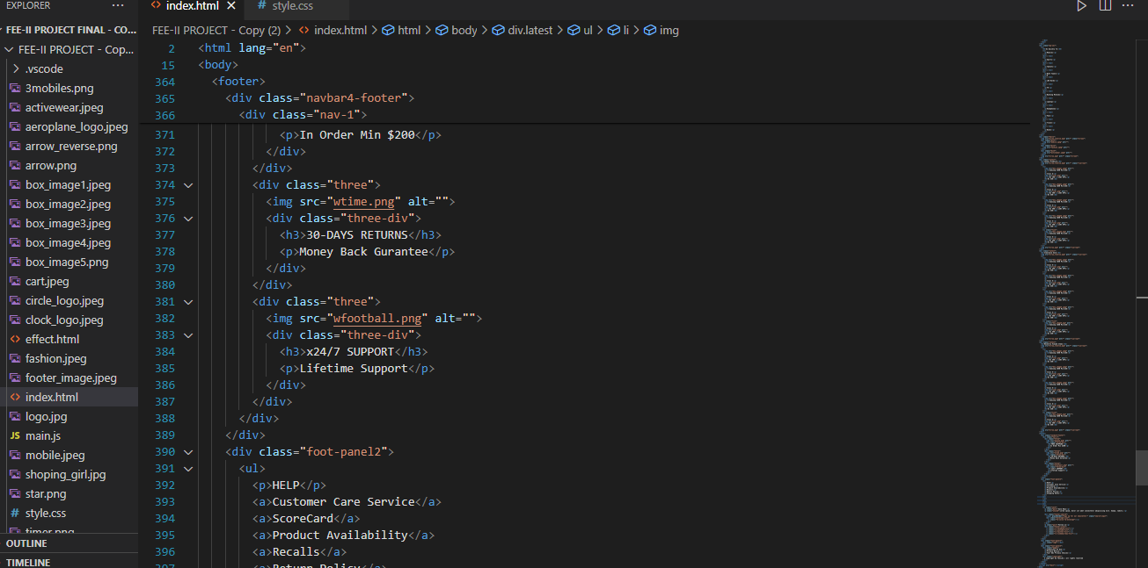

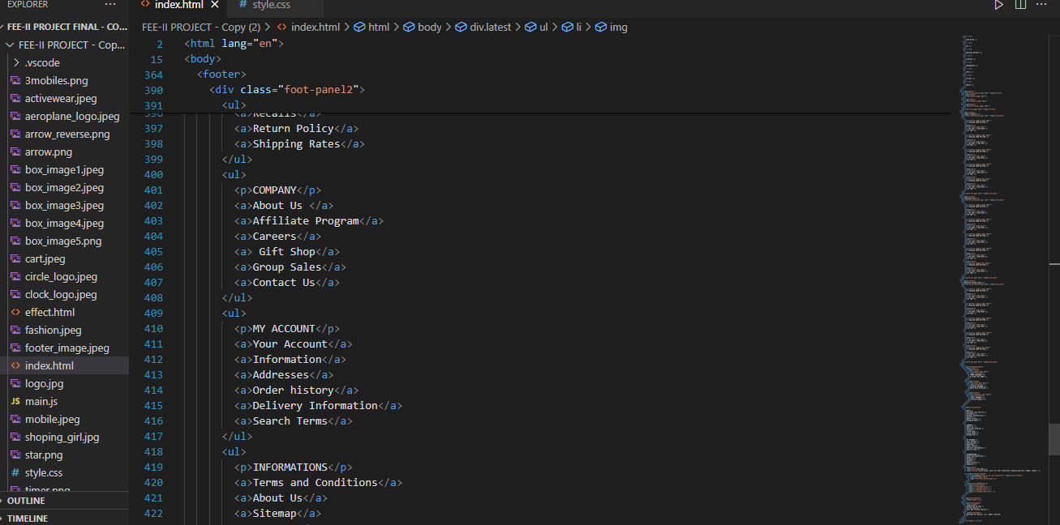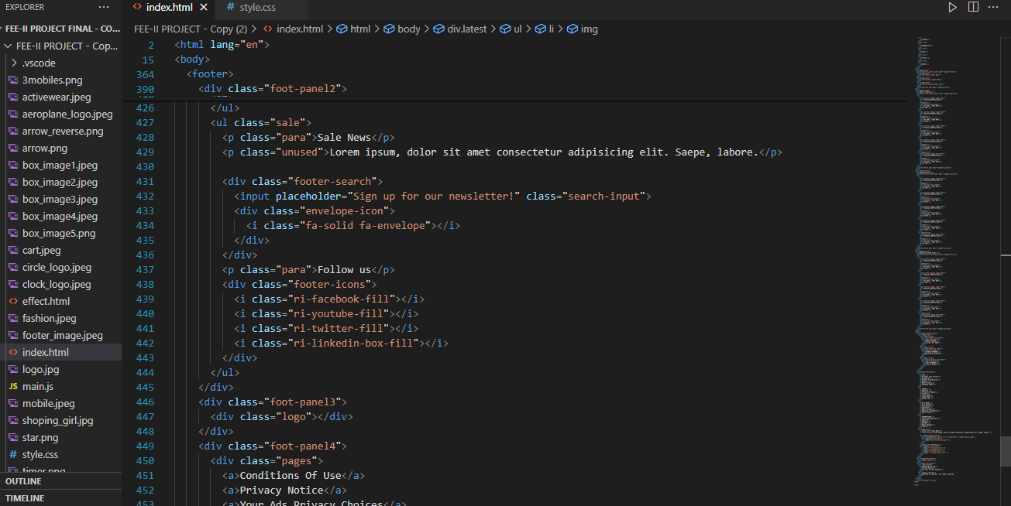

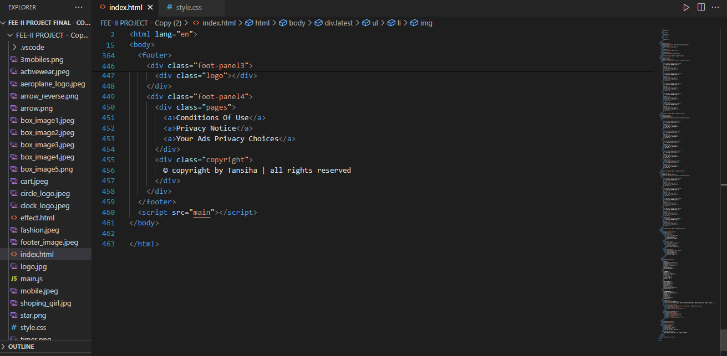

**CSS CODE: DESKTOP**

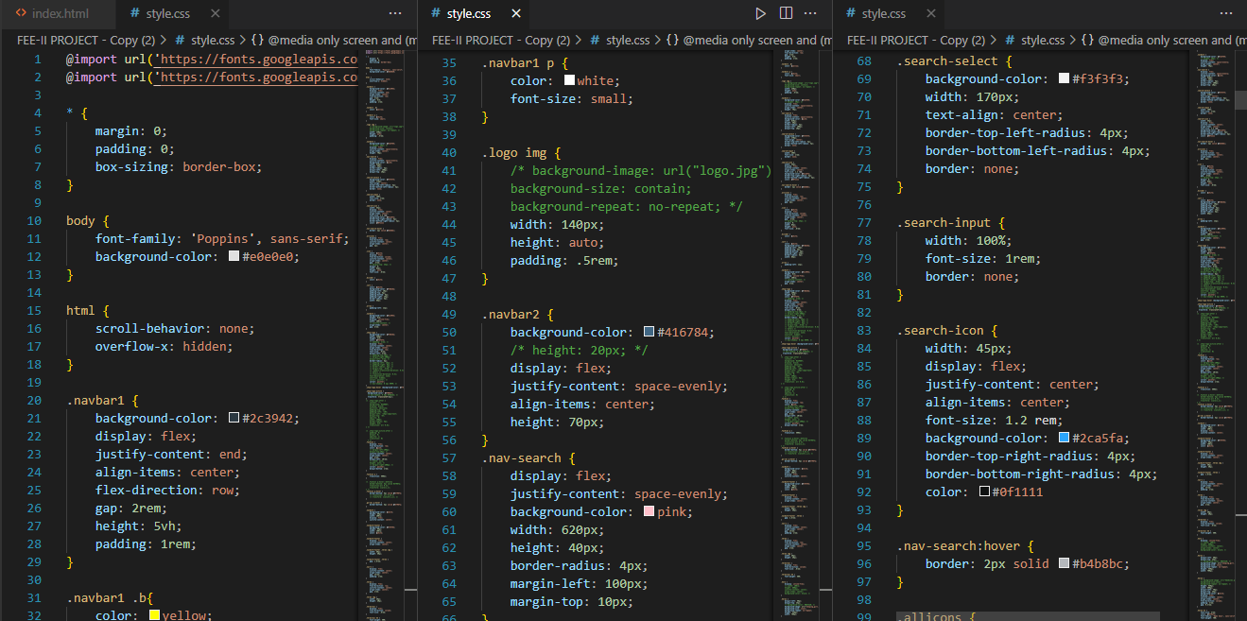

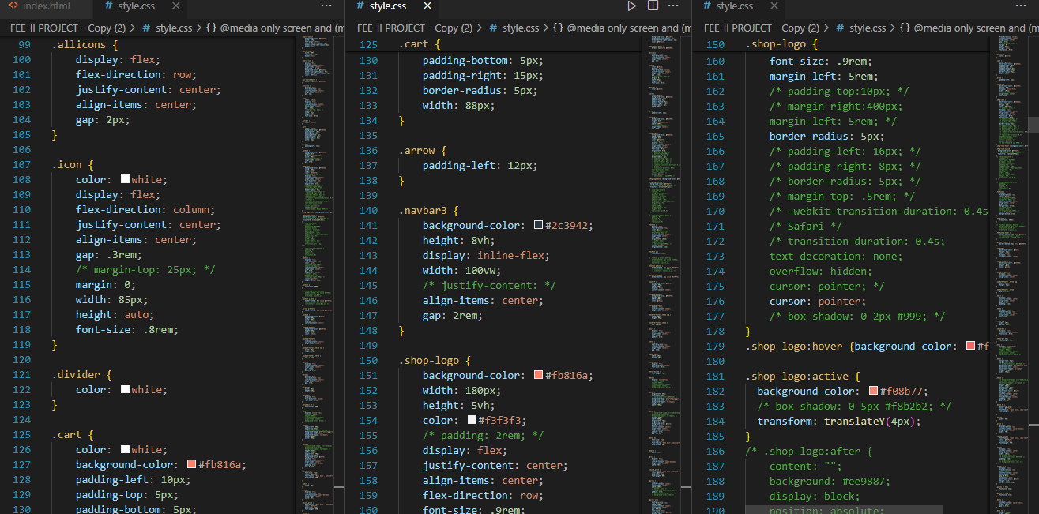

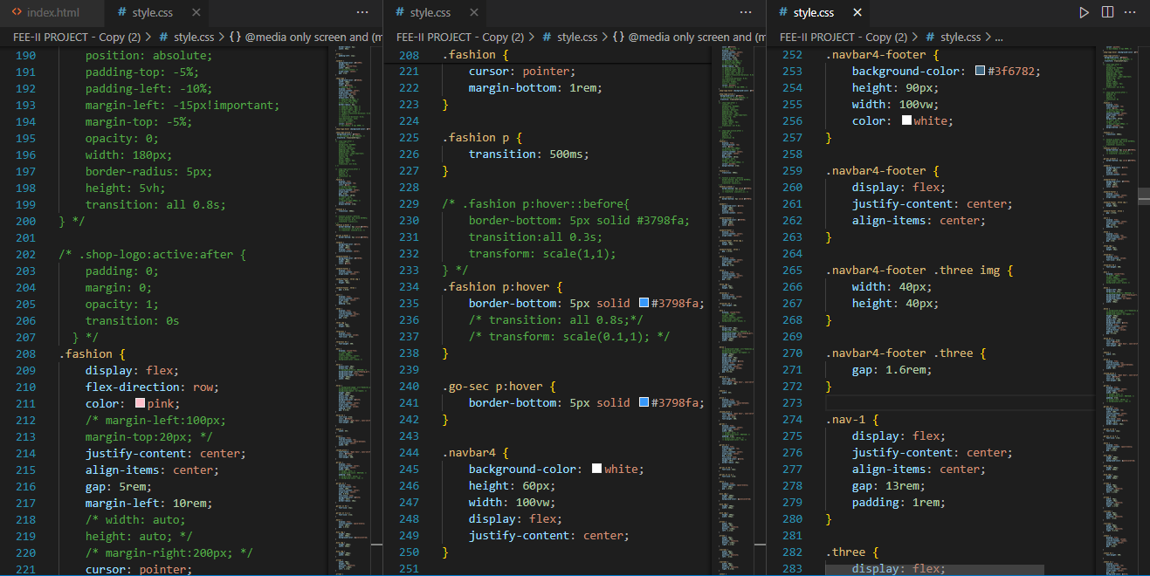

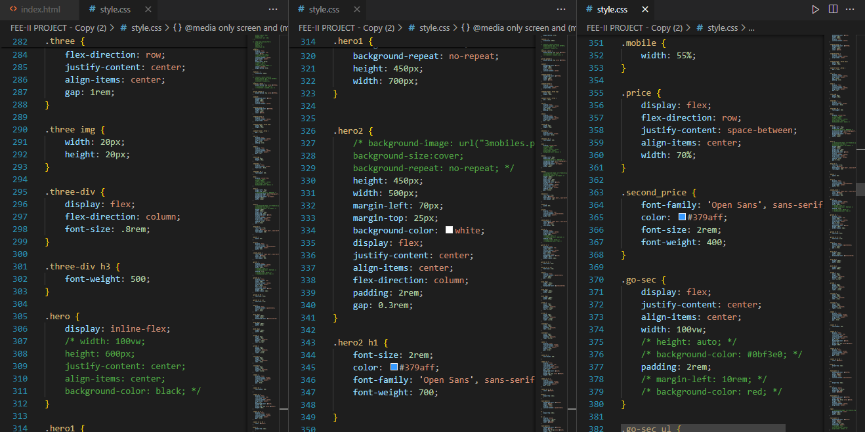

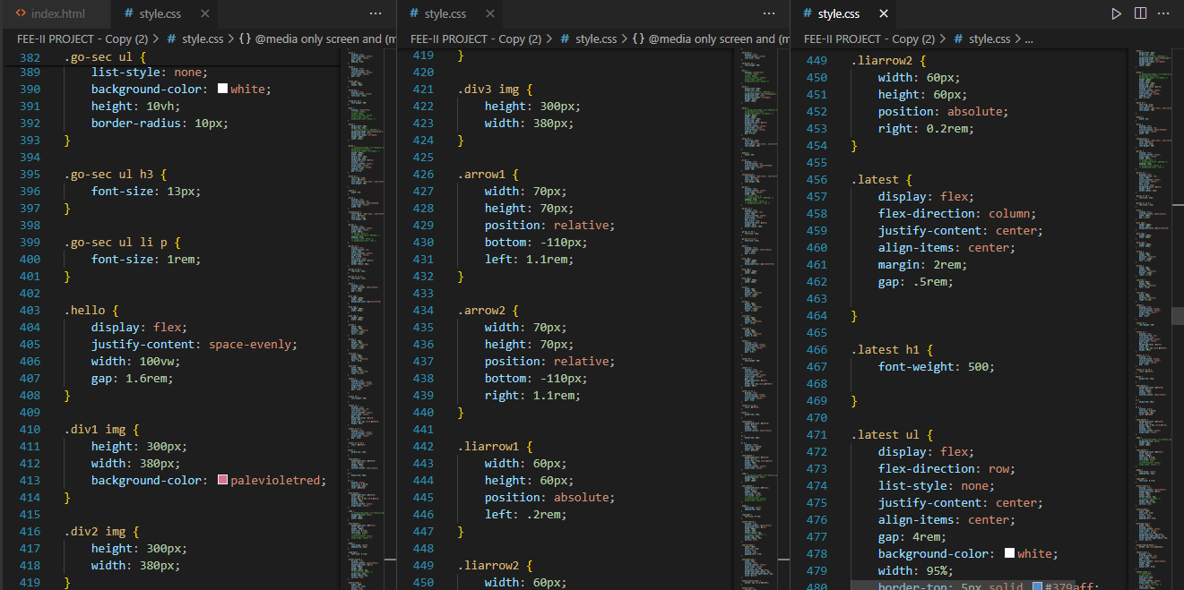

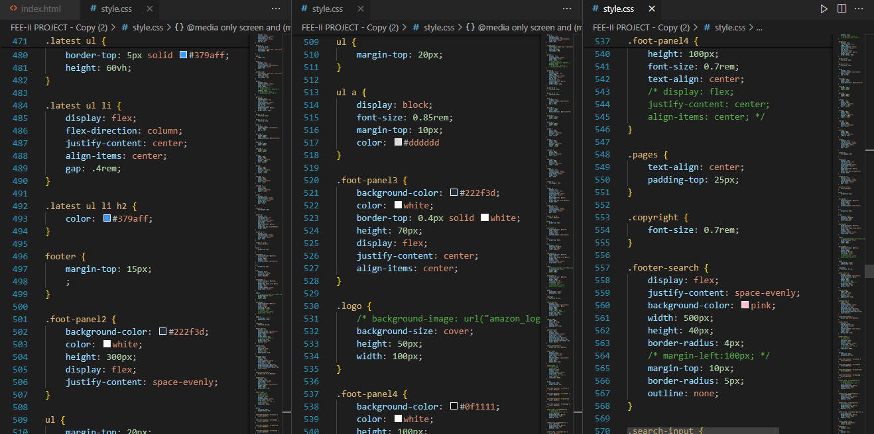

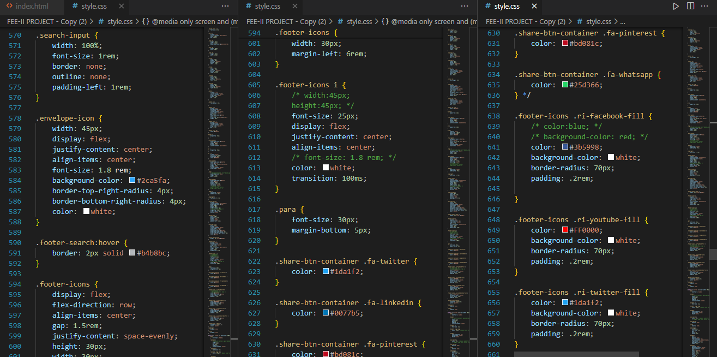

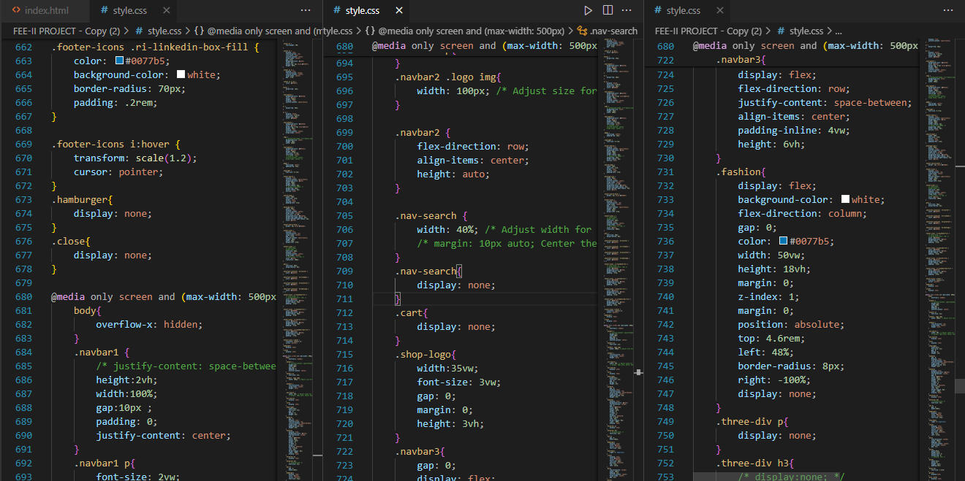

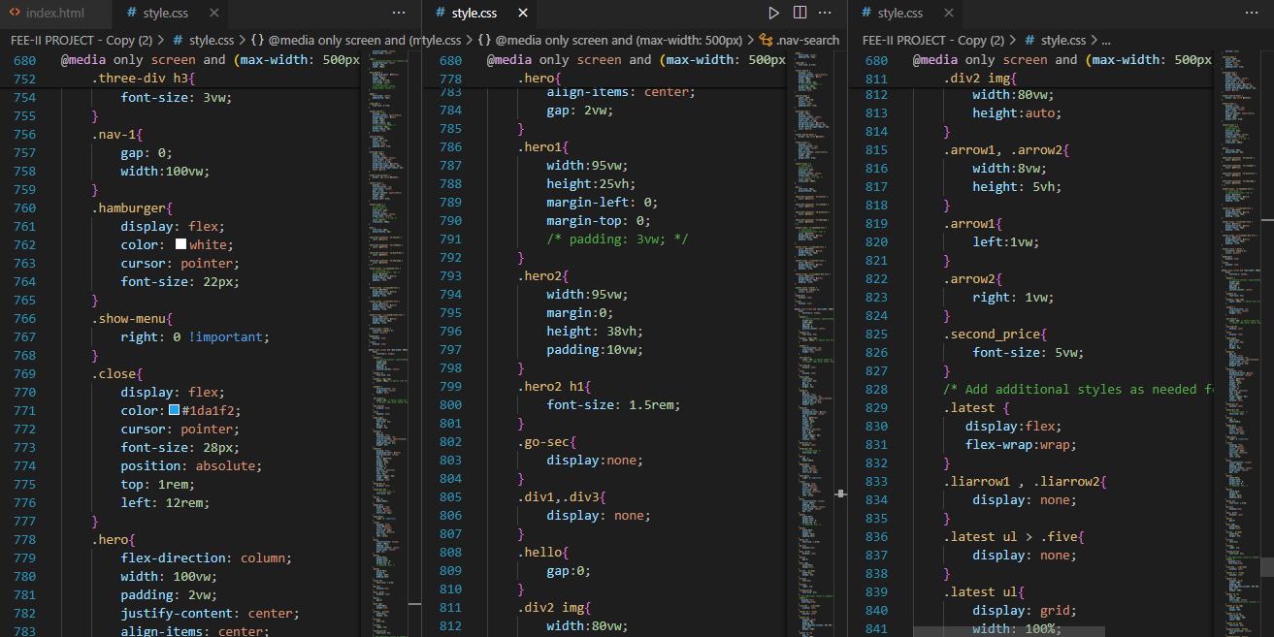

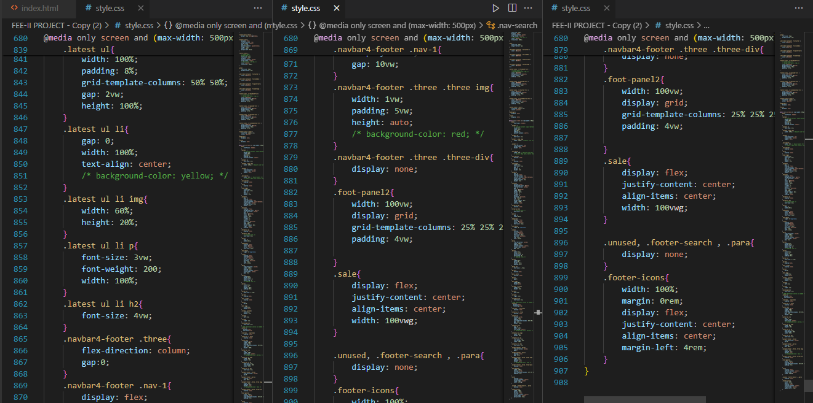

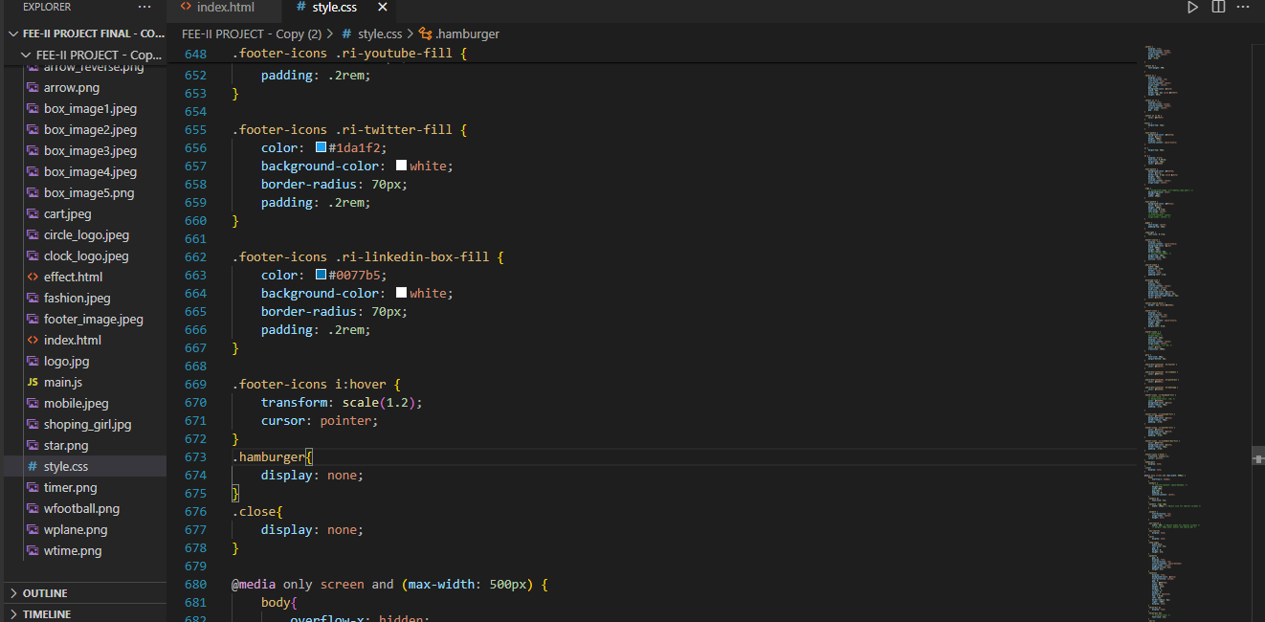

C**SS CODE : FOR MAX WIDTH:500**

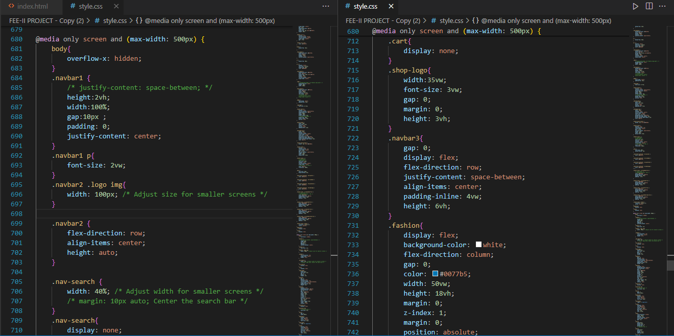

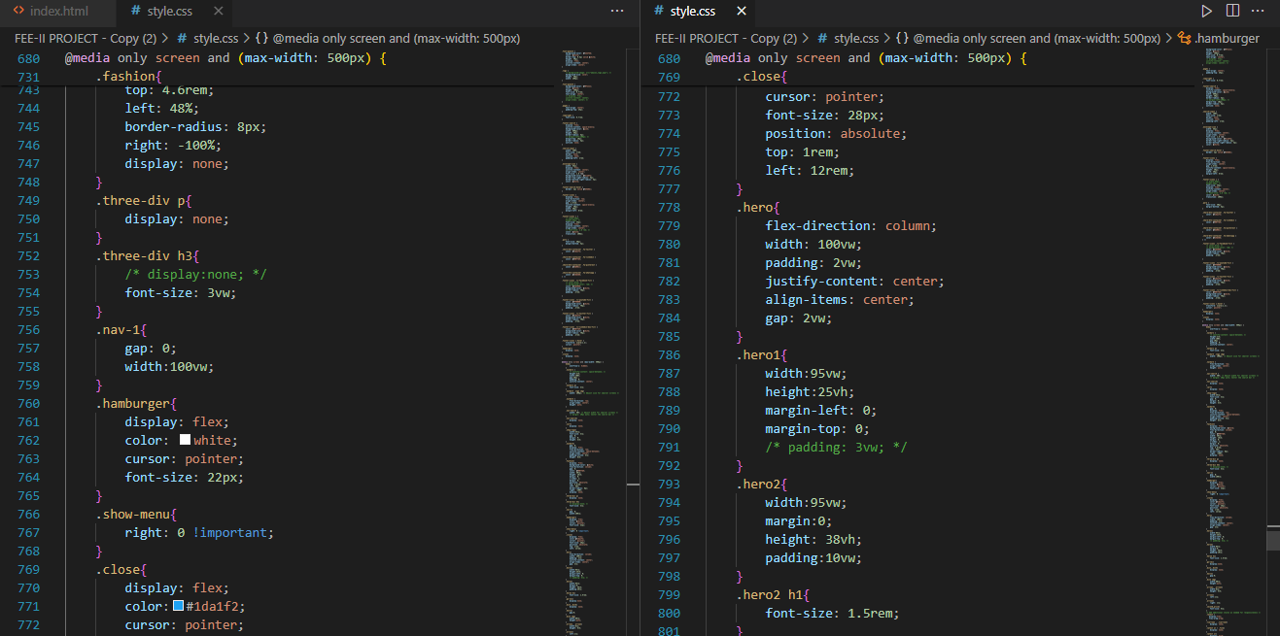

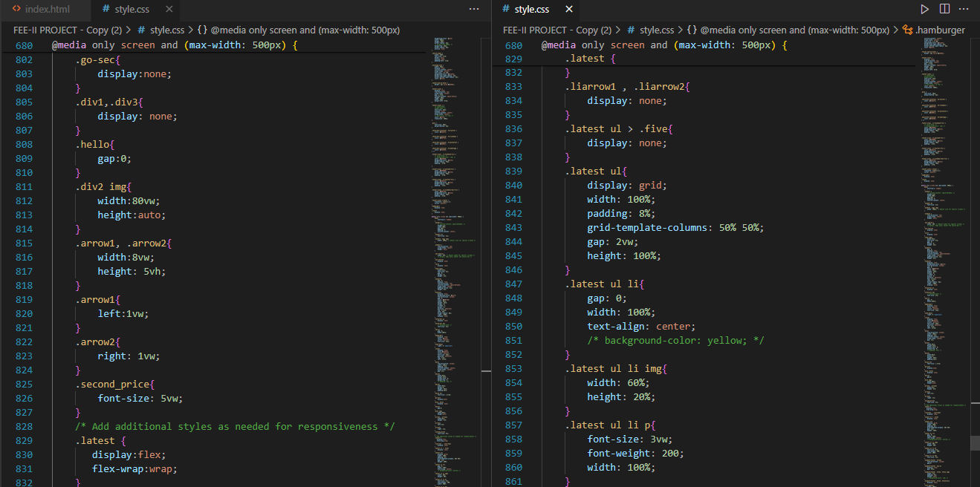

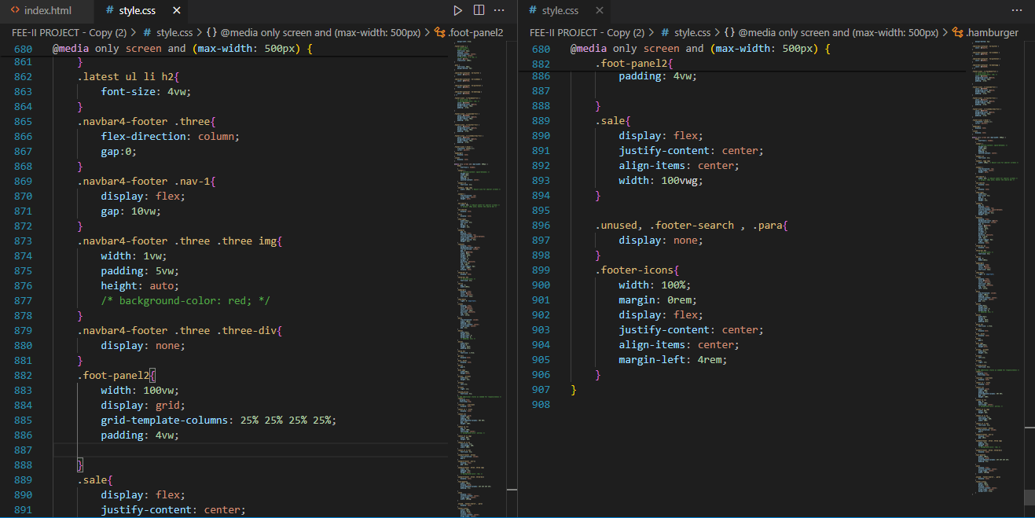

**RESULT:**

DESKTOP

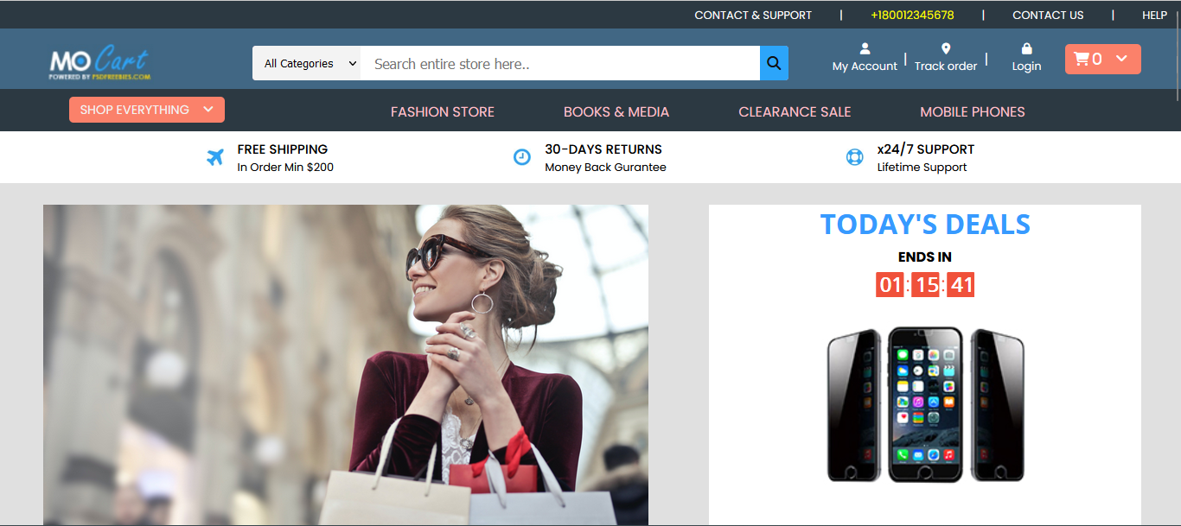

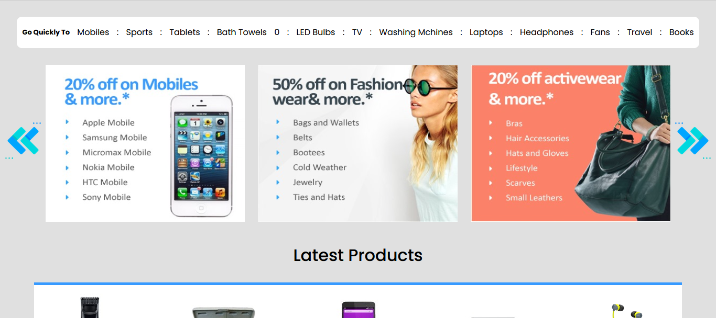

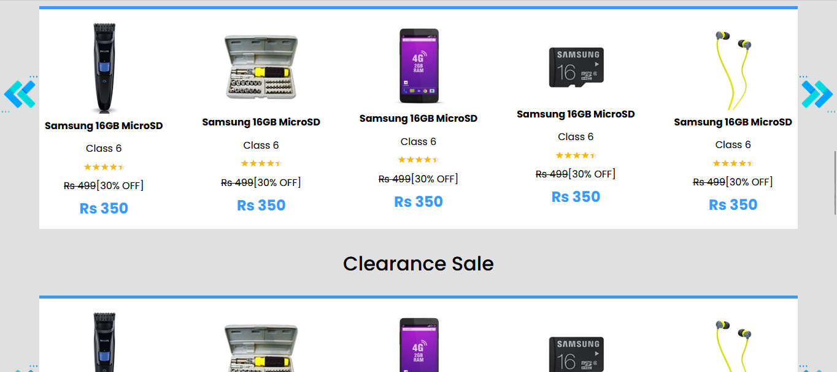

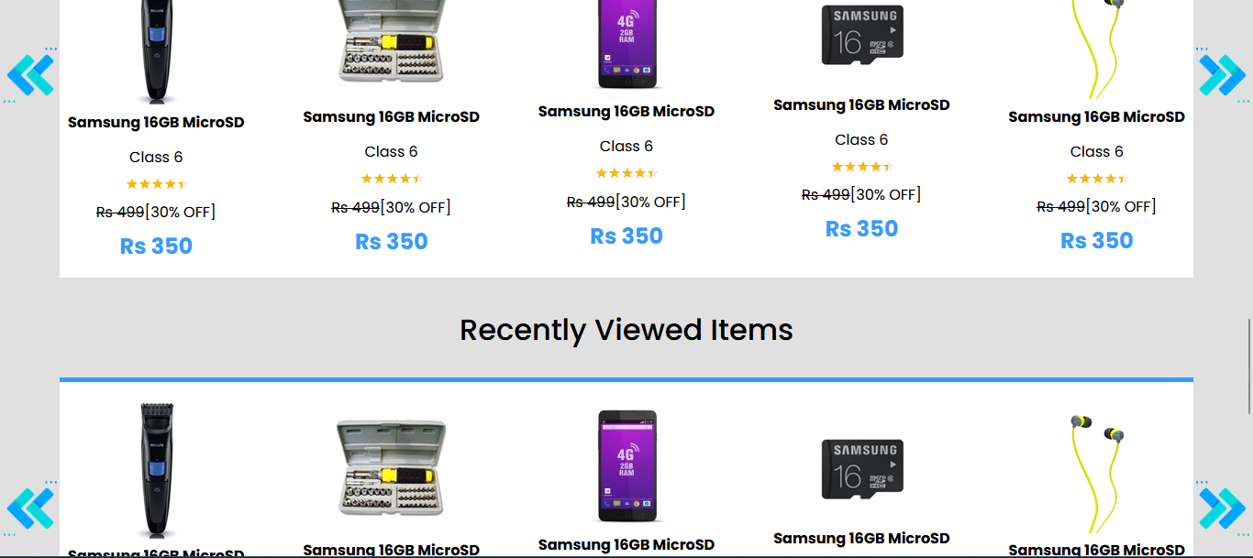

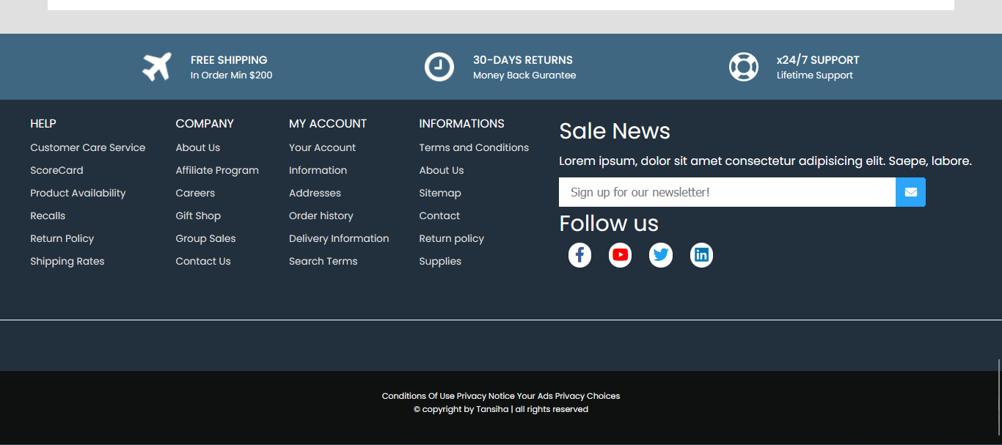

**FOR MAX WIDTH: 500**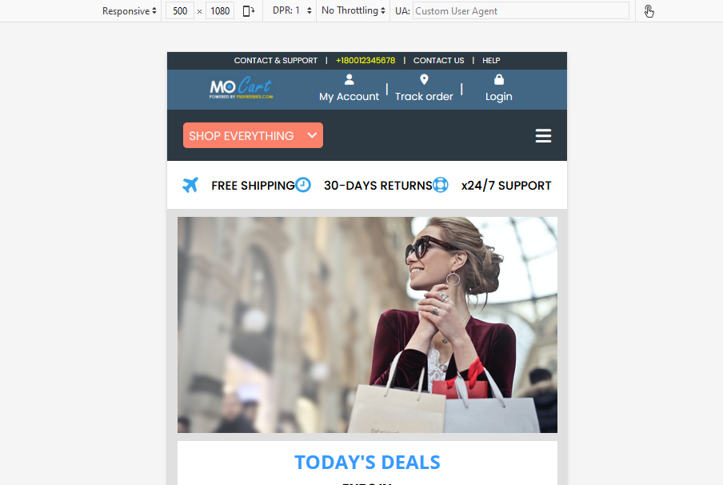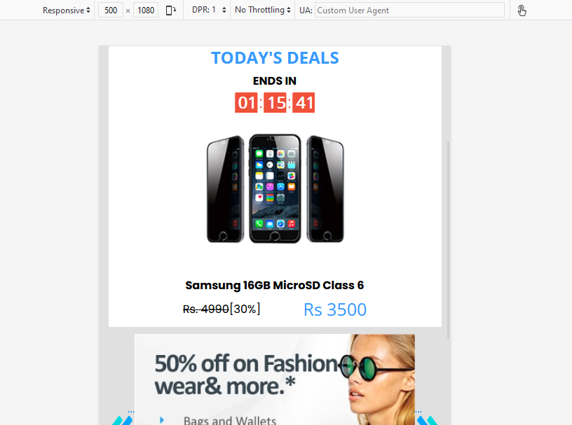

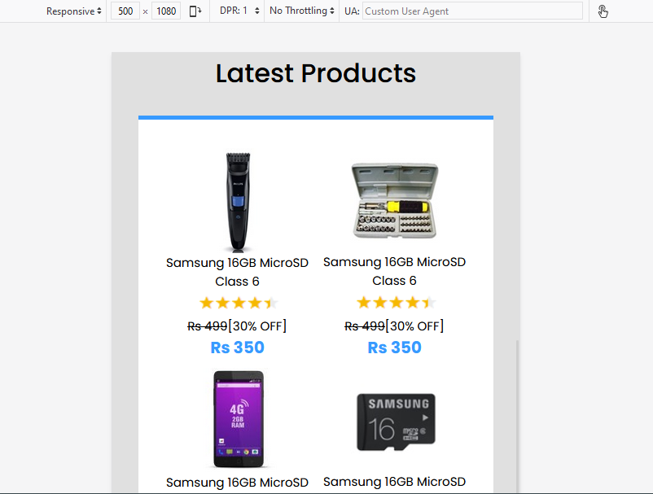

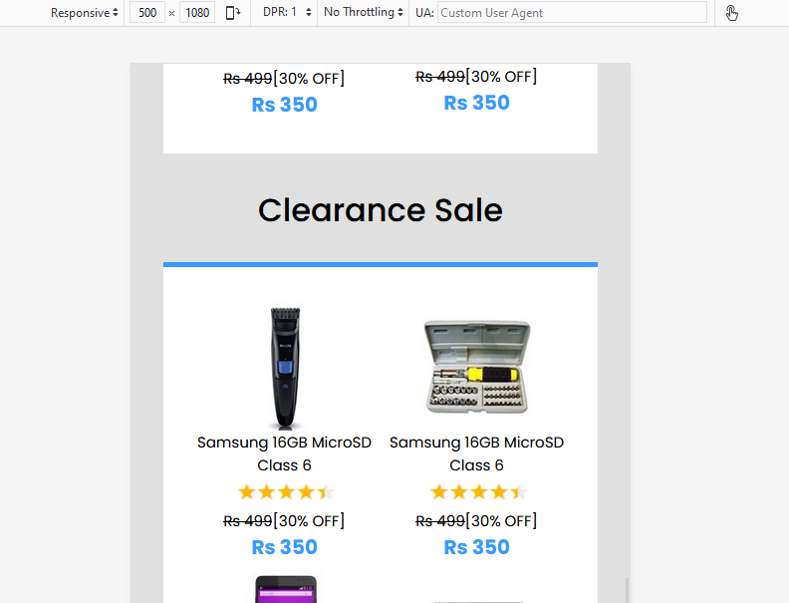

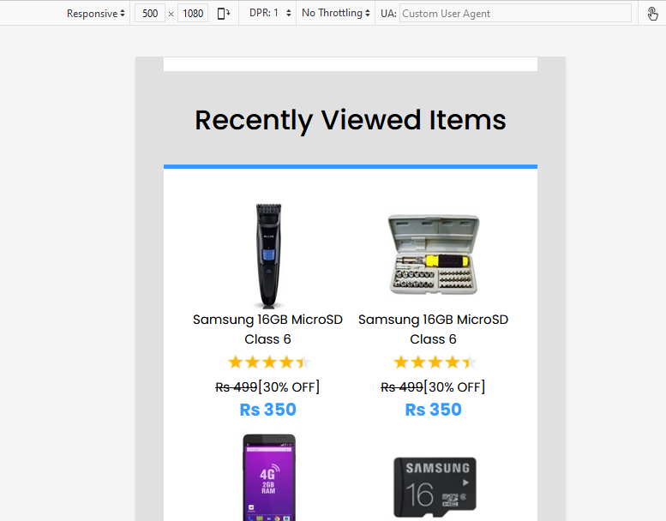

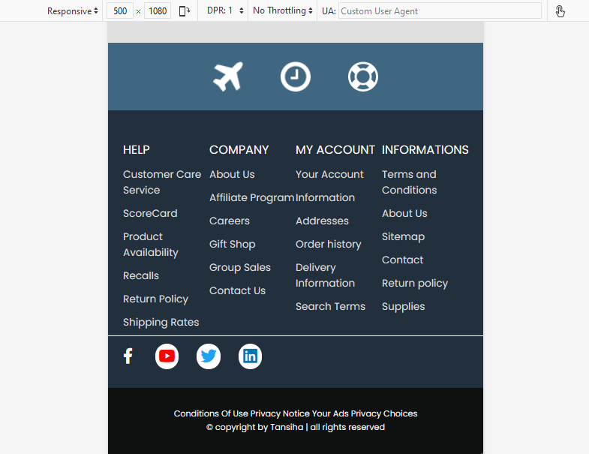

**Reference:**

**1.** [**https://www.photopea.com/**](https://www.photopea.com/)

**2.** [**https://fonts.google.com/**](https://fonts.google.com/)

**3.** [**https://remixicon.com/**](https://remixicon.com/)

**4.** [**https://fontawesome.com/**](https://fontawesome.com/)